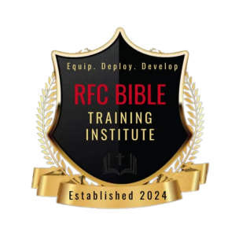
RFC BIBLE TRAINING INSTITUTE
______________________________________________________________________
REGISTRATION FORM FOR CERTIFICATE COURSES

EMAIL THIS FORM TO: rfcbibletraininginstitute@gmail.com

Date:

Last Name: First Name:

Address:

City: State:

CONTACT INFORMATION
Telephone: Work Number:

Cell Phone: Other:

Email:

Please list the course(s) that you are registering for. Courses are online and available for four-weeks, 6 weeks, 8weeks on RFC Bible Training Institute’s educational platform. Upon successful completion of course, you will receive a certification of completion from RFC Bible Training Institute.
Course Title | Course Number

Each Course Manual Price $15. Payment options are listed below. Upon receipt of payment, you will receive student manual in class.
Please email, The President, Apostle Immanuel McCoy at: apostlemccoy10@gmail.com for additional information.
Please send Registration fee as well as fee for your manual.
PAYMENT OPTIONS

Cash App: $RFCGlobalMinistries

Thank you and God bless.

