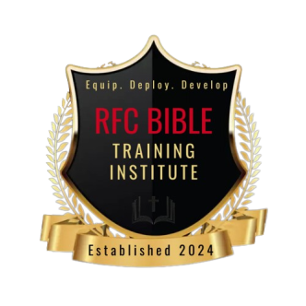

Certificate of Completion Application for Admission

RFC Bible Training Institute (RFCBTI) provides equal education opportunities without regard to race, color, national origin, sex, age, special need, or veteran status. RFC Bible Training Institute reserves the right to make a decision about whether or not to admit an applicant.
DIRECTIONS: Please complete the entire application. Missing information may cause delay or deny admission. There is a $25 non-refundable application processing fee. When submitting this application, please pay Application Fee as follows:

Cash App: $RFCGlobalMinistries

Please Note: Application will not be processed until fee is received
Upon completion, email form to: rfcbibletraininginstitute@gmail.com

Today's Date:

PERSONAL INFORMATION:

Full Legal Name:

Last: First: Middle

Previous Legal Name(s):

Mailing Address:

City: State: Zip Code:

You Telephone Number: Cell Phone Number:

Work Number:

Your Email Address:

Emergency Contact Information

Contact’s Full Name:

Contact’s Number:

Contact’s Relationship

Marital Status: [check one]
____Single
____Married
____Separated
____Divorces
____Widowed

Gender:

____Male
____Female

Please indicate race/ethnic background:
____Black or African-American
____Asian
____Hispanic or Latino
____Native Hawaiian
____White
____Bi-Racial
____Multi-Racial

Are you a United States Citizen?
____Yes
____No

If no, please complete question below
If not a US citizen, are you a permanent resident of the United Sates and what is the country of your birth?

SPIRITUAL INFORMATION
Are you a born-again Christian as described in John 3:17. If yes, please the year that you were born again.

Have you received the baptism of the Holy Spirit as described in Acts 2:4? If yes, identify the year received.

Please list your home church’s name:

Name and title of spiritual leader

Church address:

EDUCATION INFORMATION
Select the Certificate of completion program that are you applying for
____Associates Certificate
____Bachelors Certificate
____Master’s Certificate

Name of high school attended:

Address: City: State: Zip:

Graduation year:

Please list the following for all undergraduate colleges/universities that you attended/graduated:
Name and address of institution

Type of Institution (Secular or Christian):

Type of degree received:

Year of graduation:

Dates attended (To/From):

GPA:

Please list the following for all Graduate colleges/universities that you attended/graduated:
Name and address of institution:

Type of Institution (Secular or Christian):

Type of degree received:

Year of graduation:

Dates attended (To/From):

GPA:

PERSONAL REFERENCES

Please list three personal references (non-relatives);
1.
Full Name
Address:
Contact number”
Association:

2.
Full Name
Address:
Contact number”
Association:

3.
Full Name
Address:
Contact number”
Association:

What do you consider the most important factor in your decision to apply to RFC Bible Training Institute?

PLEASE READ PRIOR TO SIGNING:
Please read prior to signing:
I hereby certify that to the best of my knowledge the foregoing information is true and complete without evasion or misrepresentation.
I understand that if found otherwise, it is sufficient cause for rejection or dismissal. If my application for admission is approved, I agree to abide by the present and future rules and regulations, both academic and nonacademic, and the Godly and scholastic standards of RFC Bible Training Institute. I further acknowledge that if I fail to adhere to these regulations or meet these requirements, my admission may be revoked.
SIGNATURE (type your name in space below)

SIGNATURE:

